 

Western University Faculty of Engineering

Studio Section 13 – Safwat Ramadan

Team Identifier: T13Hide

Team Members: Samuel Reed, Melissa Fruci, Russell Robertson, Jason Adams, Nikhil Arora, Elijah Cook

Project Title: The Pelee Hut

An accessible and environmentally conscious bird hide for the Pelee Island conservation site.

# Need / Challenge

For the winter term design project our team was tasked with constructing a bird hide for the NCC (Nature Conservancy of Canada). A bird hide is a structure which provides visitors to a nature conservation site to view wildlife without them being able to see the people inside allowing for closer encounters with wildlife. Our clients wanted a design concept for hides they plan to install on their Pelee Island site. Due to the prevalence of existing hides our clients wanted a structure which would provide the base functionality achieved by all hides (namely a comfortable space which shields people from being seen and can be used for photography) and integrate it into the environment so as not to affect the local ecosystem as much as well as being an accessible site for all who visit the island. These wants expressed by our client led to the iteration and creation of our needs statement:

The Nature Conservancy of Canada (NCC) needs a way to create a nature hide that blends in seamlessly with the surroundings which can hold 4-8 people and is wheelchair accessible because the NCC wants a way for all the visitors of Pelee Island to be able to experience nature without disturbing it or detracting from the natural beauty along with improving relations with their donors.

*Figures 1a & 1b* feature hide designs from The Wild Deck Company Ltd. which is a company that constructs bird hides. Neither of these designs would be acceptable for the NCC as demonstrated by their need statement above as they would not meet the extra requirements required. Notice how in Figure 1 the hide takes up a considerable amount of space decreasing the total available wildlife space. This goes directly against our clients need for the hide to try to limit disturbances to the local ecosystem. Notice how in *Figure 2* the design has stairs leading to the entrance. Once again this does not meet one of our client’s core needs for the hide to be accessible to the range of people who will visit the Pelee Island conservation area. This emphasizes the NCC’s need for an external design that can focus on their specific and unique needs.

Figure 1a: Hide Bay Hide, (The Wild Deck Company Ltd., n.d.)1 Figure 1b: Pagham Harbour Hide, (The Wild Deck Company Ltd., n.d.)2

# Final Design Documentation

## CAD Model

Our design can be seen in its totality, both exterior and interior, here: [OnShape Model](https://cad.onshape.com/documents/faa1af42794736f11e3b505e/w/640f3de7efa3091e6ba30bec/e/2ea7699ebfeff3073229cbcc?renderMode=0&uiState=6249d0e7c3e85c5d4c7e0256)

The design has two assemblies, one for the interior and one for the exterior Figure 2.

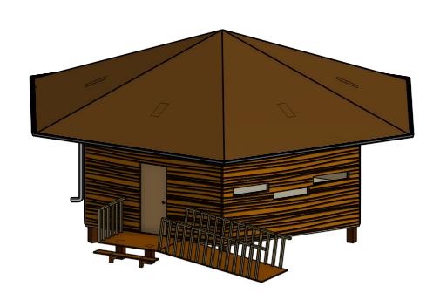

Figure 2: Exterior and Interior CAD Assemblies

## Suggested Materials

The “Pelee Hut” is a hexagonally shaped building which would be primarily constructed of cedar wood. Cedar is preferable due to for this design as the wood is rot resistant and known for its long service life even in damp conditions like those found on Pelee in the absence of chemical treatment. Chemical coatings are to be avoided at all costs in this project the hide’s location means leaking chemicals could harm the wildlife visitors are meant to see from it. The longevity of the wood would also limit the amount of maintenance/additional construction required on the site and overall decrease the amount of disturbance caused to the local environment. While cedar would represent a larger upfront investment for the NCC, the long life of the wood (up to 20-25 years) and its lack of dangerous chemical coatings make it the best choice for a structure in such a fragile location (Benefits of Using Cedar Wood, 2020). The other major construction materials would be glass and the metal fittings such as screws and hinges necessary for the construction of the windows and structure. Neither of these materials pose any significant ecological risk and as such are appropriate for Pelee island.

## Roof and Ceiling Design

The hide has a conical roof with 6 leaves corresponding to the 6 walls of the hide which had a gutter along the edge. The gutter provides two main functions. Firstly, it directs rainwater away from the entrance which prevents the large amount of rain which falls over the entire structure from falling over the entrance. It also prevents water streams from falling Infront of the windows allowing for better viewing from the hide during rainstorms. This gutter possesses a leaf guard which will prevent larger debris from entering the gutter. This will decrease the total amount of maintenance required at the hide which is desirable by our clients who want minimal maintenance costs with more infrequent clogging. The water is directed to the ground through a drain spout. The different aspects can be seen in Figure 3.

Figure 3: Images of Roof Elements (Left to Right): Roof Shape, Gutters and Leaf Guard, Drain Spout on Hide Side

Between the roof and interior ceiling (separates the interior room from the roof) there is spacing which will provide a home for birds, bats, and insects to help compensate for the habitat destroyed in the construction of the hide. The clients expressed interest in providing space for a particular kind of bird, the barn swallow. Barn swallows commonly roost on the side of structures in mud nests as seen in Figure 4. Replica nests were developed and would be placed on the interior crossbars Figure 17 in appendix section 7.2. These replica nests were constructed of wooden bowls cut in half attached to a wooden plank. They were connected by drilling holes through which metal wires could be passed and tied to hold the two pieces together. In addition to the replica nests, bat boxes and insect hotels could also be placed in the structure to the clients liking and based off the other species they expect to be in the area. The large number of nesting sites within the hide would also increase the amount of birds which live in the immediate area greatly increasing the odds that visitors to Pelee Island would see animals on their hike. To prevent water damage the ceiling would have a very slight slope of about 1 degree to prevent leaks from pooling on the interior and causing damage in the long term.

Figure 4: Left, Replica Nest to be Placed in Roof. Right, Natural Barn Swallow Nest (Gotz, 2021)

## Other Exterior Elements

The hide is raised on ‘stilts’ which produces a similar gap lies between the floor and the ground. The stilts raise the hide by 0.5 meters off the ground and serve two primary functions. The first is to serve as flood protection. The area which these hides are planned to be constructed on has flooded in the past and by raising the structure from the ground damage due to low flooding would be minimal. This lowers the total amount of maintenance which would result from low flooding events and potentially avoid damage all together. They also lower the total amount of land taken by the hide as low-lying grasses and plants would be able to grow under the hide. These would provide a habitat for some of the smaller ground dwelling animals on Pelee such as snakes and salamanders. The right image in Figure 15 of appendix section 7.2 provides a photoshopped mock-up of the hide with the gap clearly visible with grasses growing beneath.

The hexagonal shape of the hide was decided upon as it would maximize the field of view out of the hide while still utilising simple shapes with straight edges that would be easy to construct. This shape was decided upon through comparison analysis as can be seen in Figure 20 of appendix section 7.3. The Hexagonal shape is also modular should the client require a larger hide as multiple instances of the Pelee hut could be linked in a honeycomb manner as seen in Figure 21 of appendix section 7.3. This is desirable for the clients as they expressed interest in scaling the Pelee Island design up for their other conservation sites.

The hide has a single entrance in the form of a simple wooden door which opens outwards. This door can be accessed in two ways. There is a single step at a height of 25 cm to the platform with the door as well as a ramp which will be discussed further in the accessibility section. These to entrance methods are bordered with handrails to lower the risk of people falling and injuring themselves. To increase traction, especially in wet conditions, a gripping spray such as “R.C. Musson Outdoor Stair Tread Adhesive” would be applied to both the ramp and stairs. Figure 5 below shows the front of the hide with the two entry methods boxed in red.

Figure 5: Highlighted Entry Methods

## Accessibility

It was critical that the Pelee Hut be accessible by people of all abilities/conditions as our clients believe the nature and beauty of the island should be available to everyone. In order to achieve this, the hide is designed with the industry standard incline (Less than 1:12, (The Ontario Building Code | Ramps, 2008)) for the entry ramp, as well as industry standard door width and height. This allows the hide to be accessible by people in wheelchairs or who are otherwise limited in their mobility (unable to do stairs).

On each of the internal walls there is a lower window at the average viewing height from a wheelchair which is 1.1 meters on the lower end (National Disability Authority, 2020). There are also small viewing stools on the inside of the hide which are not attached to the floor and can be moved around. These viewing stools provide an extra 30 cm of viewing height and will allow small children with the ability to see out from the windows without their parents’ assistance and as such improve their experience. The sketch describing window dimensions can be found in Figure 18 of appendix section 7.2.

## Internal Elements

At the centre of the hide’s interior is a hexagonal support column. Attached to this column are two partition walls. The purpose of these three devices is firstly to segment the space to make it feel less ‘empty’, as well as to increase visitors’ sense of privacy. Secondly, it is to provide a surface on which to place posters and signs which give information about local wildlife, or which attempt to encourage visitors to do things like properly dispose of their garbage (this is a part of our risk mitigation strategy). Figure 6 illustrates an example of media the NCC could put in the hide. Lastly, this partition

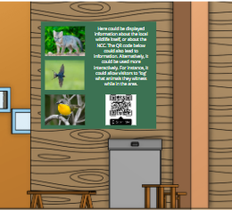

Figure 6: Mock Poster Placed on Partition Wall

would restrict the ability of light and motion on one side of the hide to be seen through windows on the hide’s other side. This restriction would help mitigate disturbances to local wildlife. Placed against these internal walls is the hide’s garbage disposal bin. This bin would have an animal safe opening mechanism to prevent any animals from accessing the garbage. Spread throughout the hide are several sitting benches, and stools. The former’s presence is obviously aimed at increasing visitor comfort. The stools would likely be used by children, to allow them to look out from the windows, which may be above their height. But theoretically these stools could be used by anyone to boost their height, or even for sitting on. A second type of bench is fixed to the floor adjacent to the wall opposite the entrance. This bench is designed merely to be leaned back against; it acts essentially as a large wooden backrest, for people only interested in staying in hide for a short time. Figure 7 features the three different resting devices implemented in the design.

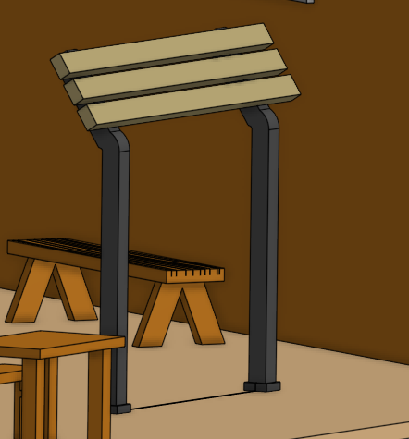

Leaning Bench

Sitting Bench

Viewing Stool

Figure 7: Image of Internals with all Resting Devices

The sitting benches and the stools would *not* be fixed onto the ground, as this is neither necessary nor helpful for their design. There is also fairly low risk that these would be stolen as the only way to access Pelee Island is by ferry making the theft conspicuous. See Figure 19 in appendix section 7.2 for a more detailed example floorplan.

## Implementation

The following is a plan for the theoretical implementation, i.e., construction, of our hide design. It is worth noting that by nature of our inexperience, all this is preceded with the advice that an actual professional engineer be consulted *before* the commencement of construction.

To begin with, as with all buildings, the foundations must be laid. Since the hide design has at its bottommost stilts which raise it from the ground, this step would entail the creation of these stilts. To do so, holes of the proper diameter (about 0.3m) should be dug in the proper arrangement of one stilt at each of the buildings’ six corners, with an additional one in the centre, keeping in mind that each wall is about 4.58 m. Within these holes would not be placed the wooden stilts themselves, but rather blocks/cylinders of concrete (Figure 8), which would then encase the bottom of the corresponding stilt. Each such foundation strut would then be buried.

Figure 8: Real Life Example of Stilts

The next step would be to place atop these seven stilts what would become the floor of the hide. To start this, the hexagonal frame of the floor ought to be placed. This would entail nailing, and attaching via brackets, planks of wood to the stilts, in the proper shape. You would then have a ‘hollow’ hexagon, without a centre, placed upon stilts. This outer frame would then have to be extended with a few beams of wood running through the middle of the hexagon. Placed across the middle could then be a sheet of wood, to provide the basis for the floor (Figure 9). Then, one would continue to ‘fill’ in this hexagon by taking more planks of wood, and stretching them across this hollow gap, and attaching them at each side of the frame, all to produce a true and solid hexagonal base for a floor (note though that gaps could be left in between these planks, for insulation). At this point the floor could theoretically be complete, as it would already be fully capable of being stood on. However, if the building is to be insulated, then more must be done. Firstly, as stated, gaps would need to exist between the planks, for insulation material to be put into. Having put said material down, one would then place more wood atop, probably in the form of a sheet with planks on top. Keep in mind that for this sort of building, insulation is not totally necessary, as no one is living in it. Adding basic insulation would not significantly raise construction costs, so it might as well be added for additional comfort.

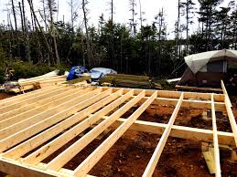

Figure 9: Real Life Example of Floor Framing/Structure

Next, the walls would have to be constructed. Each wall would probably best be made totally, before being raised up into its position. Again, this would begin with a frame. Each wall would then have a square outer frame, with a couple cross planks to finish the frame. Then on the side of the frame would be put a sheet of wood (Figure 10). Again, if insulation were needed, the material would be placed so that it was resting against this sheet, in between the cross beams. Then another sheet would be placed, so that the wall would be covered. Having done these steps though, you would have a fully solid wall. As such, you would in practice have to perform this construction in 5 cases with pieces cut specifically so as to allow holes in which to place three windows, and in 1 case for a hole in which to place a doorway. Said windows and door would best be bought more or less premade. The same can be said of the various things that would be place in the hide’s interior. It might be cheaper to just build the benches, but such construction is beyond the project’s scope.

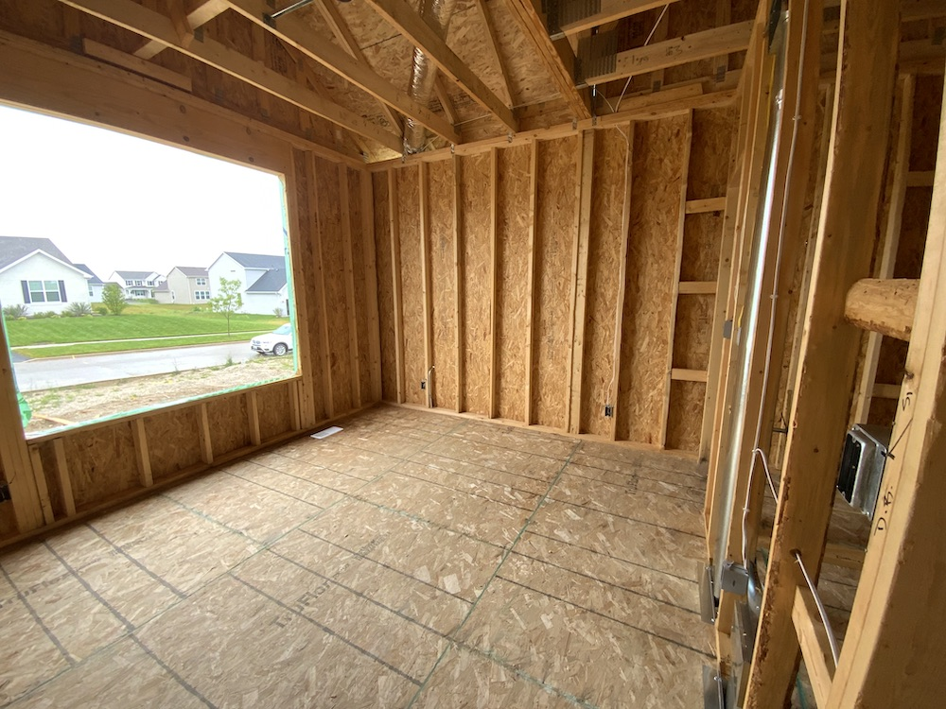

Figure 10: Real Life Example of Framing Walls

In front of the hide, the entrance ‘porch’ to which the stairs (Figure 11) and ramp leads could simply be built by driving four stakes into the ground, to form the corners of a square and then attaching some wood to these stakes. The ramp would then be a sheet of wood stretched from the ground to this platform, with the ramp being previously measured to ensure it would end up at the proper incline. Hand rails would then be made by attaching some planks pointing normal from the ramp, and then attaching those planks together with other planks. The stairs would be a couple wider planks of wood placed upon smaller planks which would be attached to the stilts of the ‘front porch’.

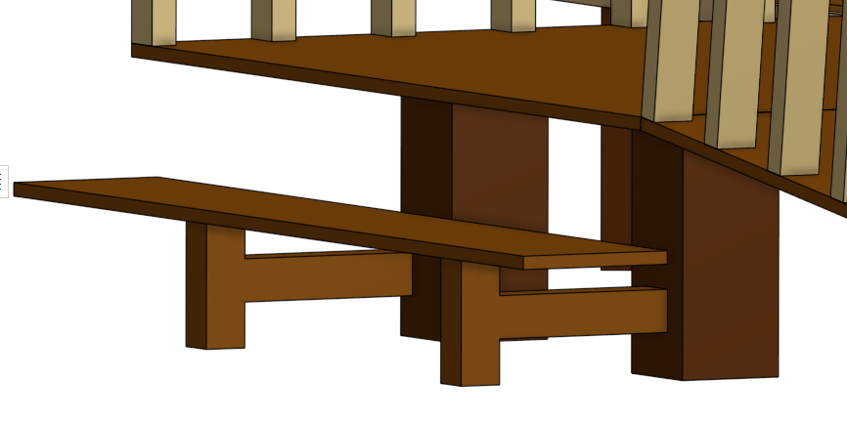

Figure 11: Close-Up of Stairs

The process for constructing the ceiling of the hide would essentially follow the same process as that of the floor, except everything would be placed on the walls rather than on the foundation stilts. In addition, there would be a central support column running from the point of the central stilt’s placement upwards through the ceiling to the roof, where it would serve structurally.

The construction of the roof, however, would prove more difficult. That process would have to begin with the construction of the frame which would ultimately serve as a nesting area for birds. This frame would involve first placing six beams going from each corner upwards at a diagonal, with each meeting at the central column. Then these would be supported with beams going up from the ceiling’s top to points along them, and by cross beams going between these diagonal main beams themselves. Then atop this frame would be placed the roof itself, intentionally so as to leave a gap between it and the ceiling. The roof could possibly be preconstructed and then lifted onto the roof, though this lifting process might prove very difficult. Regardless the roof would consist of an underlying frame wooden planks/beams, similar to the main six diagonal support beams, upon which would be placed sheets of plywood. Upon this would be placed a final layer of cedar shingles (Figure 12). A preconstructed gutter would then be attached, with a leaf guard as well. With that the roof, and the hide, would be fully constructed.

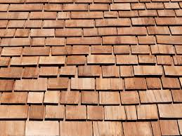

Figure 12: Cedar Shingles used as an Environmentally Friendly Alternative

# Testing and Validation

## Objectives (and Functional Capabilities)

Table 1: Objectives and Achievement Table

| **#** | **Objective** | **Assessment** | **Evidence** |
| --- | --- | --- | --- |
| 1 | Aesthetically Pleasing/Interesting Interior/Exterior | Met | The interior includes partition walls that display posters and signs that are educational and give important information. These partition walls’ other use of creating privacy between the visitors along with providing a less empty feeling allowing for an interesting interior. The overall symmetrical wall, roof, and ceiling shape creates an aesthetically pleasing look of both the interior and exterior. The gutter included in the design is simplistic allowing for |
| 2 | Keep the costs low | Met | In the hide design we decided to use a gutter. With the use of the gutter the cost of Maintenance and overall costs will stay low. With the average salary of a janitor being $15.97/hour (Job Search Canada, 2022), there is savings in this section. With much of the hide being made with cedar, which is an average pricing wood, the costs are kept low with this wood choice. |
| 3 | Blend into the surrounding environment | Not-met – could blend in better. | As seen in Figure 7 and Figure 8 the hide does not blend in at all and sticks out from the surroundings. There are no camouflage aspects in the design and the hide is large. The partition walls keep the light and motion going from one window to the other to avoid disturbance. |
| 4 | To be comfortable for long periods of time | Exceeded | The design of the hide features stools, two different types of benches (leaning/standing and sitting), partition walls and coat racks as seen in Figure 6 and Figure 7 These features allow someone to sit down, take their coat off if necessary, and enjoy the view for long period of time while feeling along even if there are people at other sides of the hide. |
| 5 | To be environmentally friendly in material and construction |  | Many hides use chemically treated wood that is very good at resisting rot and water damage. However, we decided against this as we found chemically treated wood is often unsafe as the chemicals can leak into the soil and spread into the surrounding ecosystem. By using almost entirely cedar wood in construction of the hide and transporting materials on a ferry that makes regular trips daily, the construction and maintenance of the hide has a very minimal negative impact on the environment. Additionally, the hide does not require any existing habitats to be changed during construction. It is equipped with space below and above that encourage small animals to nest in the roof or below, which improves the wellbeing of animals and nature enthusiasts. |
| 6 | To be low maintenance | Met - could reduce maintenance furthermore | With signs that promote proper disposal of trash, the typical values and behaviors of nature enthusiasts, and animal resistant garbage cans, we heavily reduced the amount of regular maintenance needed. With a design that promotes longevity due to resistance to flooding, rot, water damage, and animals entering the hide, there will be little maintenance needed under normal circumstances. One aspect that was overlooked was how to clean the area in the roof with nesting cups (Figure 17). There is currently no easily accessible manner for cleaning what mess birds or other small animals may make inside. |
| 7 | To have a scalable design | Met | This hide is very simple in its geometric architecture, and due to its shape, is easily repeatable. As seen in Figure 21, there are many ways you can add an instance of the hide to create various shapes with their own unique field of views. Furthermore, the hide can be stacked vertically to create a hide with many levels. |
| 8 | To be long lasting | Met | The thorough planning and designing of the hide allow it to have a low impact from those using it as well as its environment. Being raised off the moist ground allows the hide to be very resistant to water damage and flooding. Additionally, the hide is built with cedar wood, the most rot resistant wood, preserving the hide from rainfall. Any open, unprotected ends of wood planks are fitted with aluminium caps to prevent rot on these more rot prone areas. With the hide being built with additional features and out of materials that promote longevity and low maintenance, we met this objective. |

## Testing and Validation: Constraints

Table 2: Constraints and Achievement Table

| **#** | **Constraint** | **Assessment** | **Evidence** |
| --- | --- | --- | --- |
| 1 | Accessible to people with disabilities | Met | Design featured a ramp to the entrance in accordance with the Ontario Building Code section 3.8.3.4 following constraints around slope and width (The Ontario Building Code | Ramps, 2008). |
| 2 | Must not disturb the wildlife | Met | Many systems were implemented which increase the usability of the hide by both people and animals. The wild animals of Pelee island were researched through the client’s online resources and it was found that there were a variety of rare birds, salamanders, snails, and more (Discover the plants and animals of Pelee Island, 2020). To provide space for the birds artificial nesting cups were placed in the spaced roof while the space between the ground and the hide would provide space for the smaller species of Pelee to live shielded from avian predators, see Figure 17 in the appendix section 7.2. |
| 3 | Suitable for Pelee Island | Met | The structure was raised off the ground to prevent damage due to flooding. The structure would be constructed from non-chemically treated cedar wood to protect the natural inhabitants of the island while maintaining a long life in damp conditions (Benefits of Using Cedar Wood, 2020). |
| 4 | Must not be too big (single story, 4-8 people occupancy) | Not Met | The final square footage of the internal space of the hide was 586 sq ft as seen in Figure 13. This is approximately the size of a 3 – 4 car garage and as such far exceeds the expected size for the clients using the dimensions used in the CAD model (Prescott, 2022). Could be fixed by scaling all components used down. |
| 5 | Must not detract from the natural beauty | Not Met | The hide is very large (As seen in constraint #4) and as such imposes of the surrounding landscape a considerable amount. Comparing the images found Figure 14 and Figure 15/Figure 16 of appendix section 7.1 it becomes obvious how much the hide sticks out from the surrounding area becoming the focal point of the pictures. Some design options are available to possibly mitigate or reduce this such as a structural redesign or natural shielding. An example of a structural redesign would have to built the hide into the ground which would remove the structure the horizon and provide a more clear view of the surroundings. We also could use natural shielding and plant native trees in-between the approach to the hide and the structure itself so that the only thing a visitor would see when approaching would be a small cluster of trees. |
| 6 | Accessible viewing heights | Met | The hide features three different tiers of viewing heights to allow the greatest range of heights and abilities to be able to use the hide. The upper windows are at a height of 1.4 meter while the lower windows are at a height of 1.1 meter. This can accommodate people standing, leaning on the interior shelf, as well as people in wheelchairs. In addition, there are viewing stools in the hide that provide an extra foot of height for people visiting with small children. The sketch demonstrating the heights of the windows can be found in Figure 18 of appendix section 7.2. |

Figure 13: Automatically Generated OnShape Floor Area

# Comparison

## Comparison 1

Status Quo – No hide on Pelee Island

Table 3: Status Quo Comparison

|  |  |
| --- | --- |
| Practicality Comparison | The status quo option of having no hide on Pelee Island would be practical from a cost perspective as there would be no need for the Nature Conservancy of Canada to spend money on building and developing the hide. However, this is not practical to our hide design as the NCC wants to build its first hide on Pelee Island. Therefore, by not having a hide on Pelee Island than the client's needs are not meet making the status quo option unpractical. |
| Comparison of Strengths | The strengths of having no hide would be that there would be no construction on the conservation site. This would ensure that no animals are injured, or their habitats are not destroyed. Another strength to the NCC not building a hide would be that they would not need to worry about maintenance and repairs that would need to take place in the hide. |
| Comparison of Weaknesses | The disadvantages to the status quo option would be that the NCC does not have a place for visitors and wildlife enthusiast to come out to the island and view the nature. Pelee Island primarily attracts bird watchers as the conservation site has a variety of birds specifically Barn Swallows. A hide on the conservation site would allow bird watchers to have a place to sit for many hours and watch wildlife. If the NCC went with the status quo option, then wildlife enthusiasts would be disappointed and unsatisfied, the clients' needs would also not be meet. |
| Other Comparisons | Other than the above comparisons the status quo option does not provide people a comfortable and safe place to watch wildlife. Also, by people using the trails due to the option of having no hide then animals may get more easily scared. This would mean that people who went to the conservancy site to watch animals would not be able to do so as there would not be a place for them to watch without disrupting the wildlife. |

## 4.2 Comparison 2

Wild Deck Company Bird Hide – Refer to Figures 1a and 1b

Table 4: Competitor Comparison

|  |  |
| --- | --- |
| Practicality Comparison | By referring to part 1 Need/Challenges one can see that the Wild Deck Company builds hides for conservation sites. From a cost perspective our teams Pelee Hut would be in a comparable cost range to the Wild Deck Companies hide. This company may charge less based on our hides dimensions and the size of hides this company usually builds, however it does not meet the clients’ standards. The clients emphasized on accessibility, and figures 1a and 1b are unable to provide that accessibility, which is important to the clients. |
| Comparison of Strengths | Some strengths of the Wild Deck Companies’ Hides are that the hide is raised off the ground, which is a key factor due to the occurrence of floods on Pelee Island. Another strength their hides have are that they provide bird watchers as well as wildlife enthusiasts a comfortable place to stay and watch wildlife on the conservatory which is the main goal of having a hide. |
| Comparison of Weaknesses | The weaknesses in the Wild Deck Companies’ Hides are accessibility, along with the viewing options in their hides. As discussed, the hide does not provide a ramp for wheelchair access, which was a significant want for the NCC. Not only this but the shape of the hide is rectangular, this means that you would only be able to view the conservatory through three different sides. Our design, The Pelee Hut, provides a total of 5 walls with windows of a variety of heights on each wall. This not only meets the accessibility need of the NCC but also provides wildlife enthusiasts to have a wider range of view of the conservatory, an option that Wild Deck Companies does not provide. |
| Other Comparisons | Overall, the hides built by Wild Deck are quite different than our design The Pelee Hut. Our hide integrates with the wildlife, by providing roof access to animals so that they have a place to nest. This component of our hide has not been done by Wild Deck. Ultimately our hide does not take away from animal’s habitats as it still allows them to interact with the hide, while the Wild Deck hides are not built to allow for animals to do this. |

# Potential Improvements

There are many insights we developed as a team throughout this project that have not only allowed us to think of different ways our project could have been improved but also allowed us to develop real-life problem-solving skills as engineers. Overall, our project was successful, and we were able to satisfy our clients wants and needs. After receiving questions about our hide there are some components of our design that could have been modified for a more successful outcome.

The first improvement would be the roof where birds and animals had access to. An insight that we developed about this portion of our hide was if animals were to use this interactive roof as a restroom. After reviewing this insight about the roof, we as a team decided that if we added a tarp component on the roof floor which contained soil on top of the tarp. If animals were to mistake this interactive portion of the hide as a washroom, then the cleanup would be very minimal. With this improvement, there would probably need to be seasonal maintenance of filtering the soil that laid on the tarp

Another improvement that would have contributed to greater success of our project was developing a fence along the trail in the conservatory that leads to the hide. If we were to go back and do this project again, we agreed that we would add a fence along the trail that had a height just over the average individuals. Then once an individual got to “The Pelee Hut” there experience viewing the wildlife would be much more breathtaking. This fence would provide a separation and block people from viewing the wildlife along with blocking wildlife from people. The purpose of people not being able to see the wildlife would be so that once they got to the hide it would be their first time viewing all the beautiful nature, contributing to a better experience. The other purpose of the fence would be for the animals to not get scared or leave the area of the hide when they see people coming. It would also ensure that there were lots of animals in view once an individual was in the hide observing the wildlife. Overall, these key details in our hide would have improved our project and would have made our outcome even more successful if we were able to complete this project again.

# References

The Wild Deck Company Ltd., n.d. *Hide Bay Hide*. [image] Available at: <https://www.thewilddeckcompany.co.uk/product-portfolio/bird-hides/> [Accessed 2 April 2022].

The Wild Deck Company Ltd., n.d. *Pagham Harbour Hide*. [image] Available at: <https://www.thewilddeckcompany.co.uk/product-portfolio/bird-hides/> [Accessed 2 April 2022].

Gotz, M., 2021. *Barn Swallow and Nest*. [image] Available at: <https://www.whistlernaturalists.ca/single-post/barn-swallow-hirundo-rustica> [Accessed 4 April 2022].

National Disability Authority, 2020. *1.2 Ensure that displays are within sight of people of all heights and people sitting in a wheelchair or buggy | Centre for Excellence in Universal Design*. [online] Universaldesign.ie. Available at: <https://universaldesign.ie/technology-ict/archive-irish-national-it-accessibility-guidelines/Telecoms/Guidelines-for-Telecoms-Accessibility-Priority-1/1-2-Ensure-that-displays-are-within-sight-of-people-of-all-heights-and-people-sitting-in-a-wheelchair-or-buggy/1-2-Ensure-that-displays-are-within-sight-of-people-of-all-heights-and-people-sitting-in-a-wheelchair-or-buggy.html> [Accessed 5 April 2022].

Buildingcode.online. 2008. *The Ontario Building Code | Ramps*. [online] Available at: <https://www.buildingcode.online/517.html> [Accessed 3 April 2022].

Natureconservancy.ca. 2020. *Discover the plants and animals of Pelee Island*. [online] Available at: <https://www.natureconservancy.ca/en/where-we-work/ontario/stories/discover-pelee-island.html?_ga=2.29225150.349627565.1649009380-2080269866.1648131144> [Accessed 3 April 2022].

Northern Log. 2020. *Benefits of Using Cedar Wood*. [online] Available at: <https://www.northernlogsupply.com/log-looks/posts/benefits-of-using-cedar-wood/> [Accessed 3 April 2022].

Prescott, G., 2022. *Standard Garage Size Dimensions and SQ FT for 1,2,3,4 Car Garages*. [online] Epic Home Ideas. Available at: <https://www.epichomeideas.com/standard-garage-size-dimensions/> [Accessed 3 April 2022].

Job Search Canada. 2022. *Janitor salary in Ontario.* [online] Available at: <https://ca.indeed.com/career/janitor/salaries/Ontario> [Accessed 4 April 2022].

# Appendix A – Examples of Design Documentation

## Pelee Island Site

Figure 14: Images of the Pelee Island Hide Locations

Figure 15: Images of Blind Locations with Hide Edited in

Figure 16: More images with the Hide edited in

## CAD Models or Drawings

Figure 17: Interior of the Roof, Notice Placement of Replica Nests on Cross Beams

Figure 18: Dimensions of Windows

Figure 19: Detailed Floor Plan

## Shape Analysis

Figure 20: Shape Comparison Considering FOV from Viewing Windows

Figure 21: Examples of Arrangements to Create Larger Hides at Alternate Sites